**Data DEMONS – In class Data Exploration – 9/20/2022**

**Group members**: Adri Grow, Jailene Gonzalez, Alex Low, Sarah Guitart, Rosalyn Bathrick

* Export your plots to image files and paste them into a document along with your responses to the questions below
* Describe whether the plot shows a summary of the data, or all of the data points.
* Describe the insight your plot can provide, for example:
  + Are the data evenly distributed, or skewed?
  + If your plot contains more than one variable, does the plot reveal any interesting relationships?

Histogram

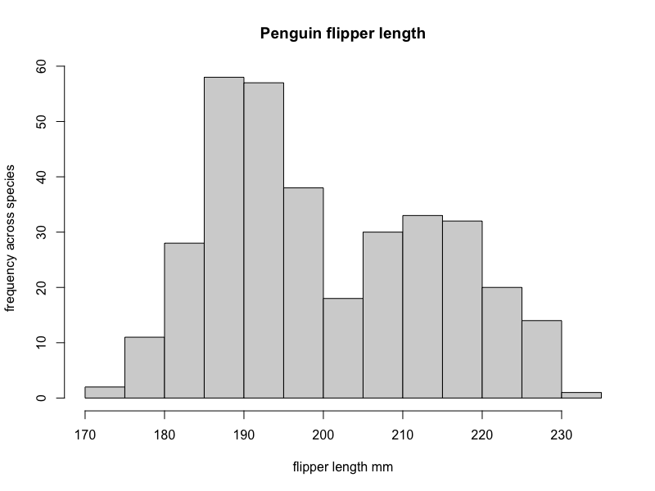

The histogram plot does not show individual datapoints – it creates bins for groups of flipper lengths. The data looks bimodal – it has two different, unequal, peaks, possibly corresponding to species or sex variables, but the data is just one variable.

Coplot

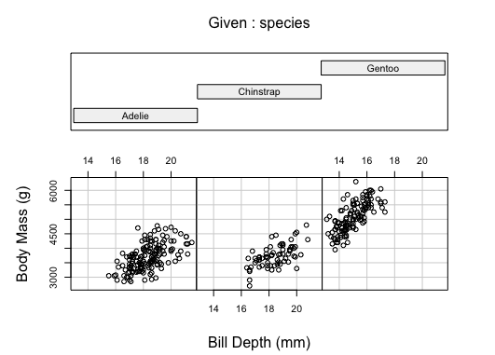

The coplot shows all of the data points, which may or may not be evenly skewed; because of the type of plot we chose, it is hard to determine. In terms of interesting relationships, the data does seem to show that Adelie and Chinstrap penguins share similar bill depth and body mass values, while Gentoo penguins had shorter bill depths and larger body masses, as well as a greater mass x bill depth ratio.